**Pratik Gupta**

**Assignments on String, StringBuffer, StringBuilder**

1. Using features of Java 11, read the data from a text file (File name: StudentList.txt). Calculate the count of students and print the names as well as the total count of students on the screen. (If any line in file doesn’t contain a name, for such a record blank space should not be printed in the output)

Hint: Use java 11 features of files and String methods to reduce the lines of code to be written.

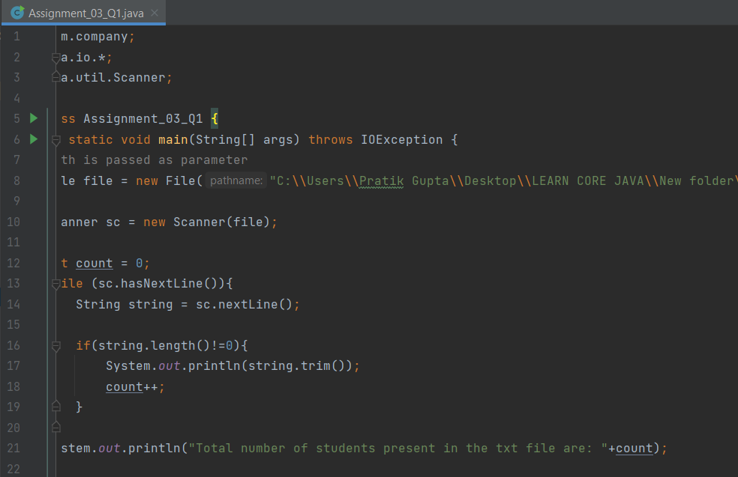

OUTPUT :-

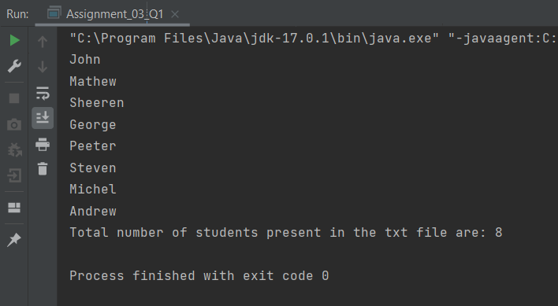

2. Write a program with menu to accept the price of certain items and display their total.

When user selects Option 1: should accept the prices of different products and insert these prices into first file (each amount to be inserted in a newline in the file). Next, total of these values should be saved in a new file. Option 2: should allow the user to view the total of these prices from the second file.

Sample Output: Select your option (1: Insert New Price, 2: View Purchase Total, 3: Exit) > 1 > Insert 1 st price: > 100 > Price has been saved to the file > Do you want to enter price for more items? (Yes/No) > Yes > Insert 2 nd price: > 200 > Price has been saved to the file > Do you want to enter price for more items? (Yes/No) > No > Select your option (1: Insert New Price, 2: View Purchase Total, 3: Exit) > 2 > Total Price of all items is: 300 > Select your option (1: Insert New Price, 2: View Purchase Total, 3: Exit) > 3 exit program…. Hint: Use java 11 features of files and String methods to reduce the line of code.

OUTPUT :-

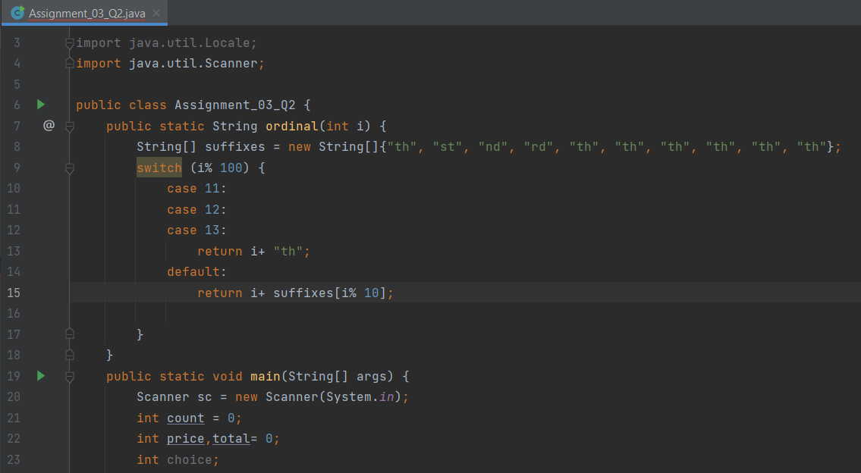

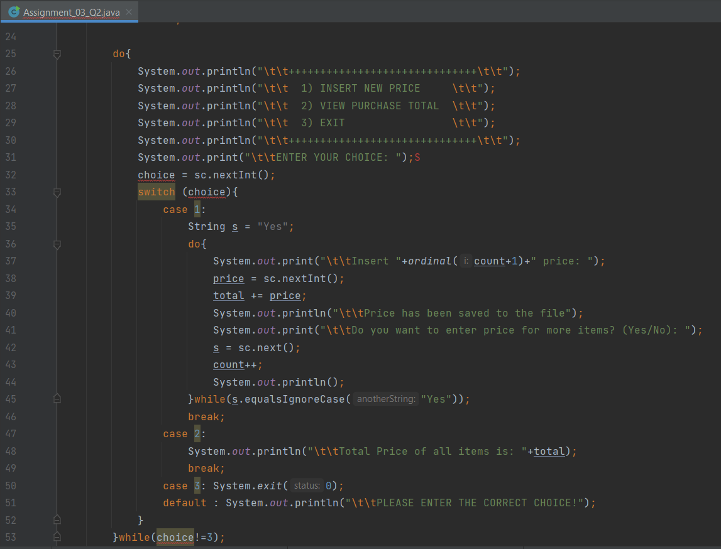

OUTPUT :-

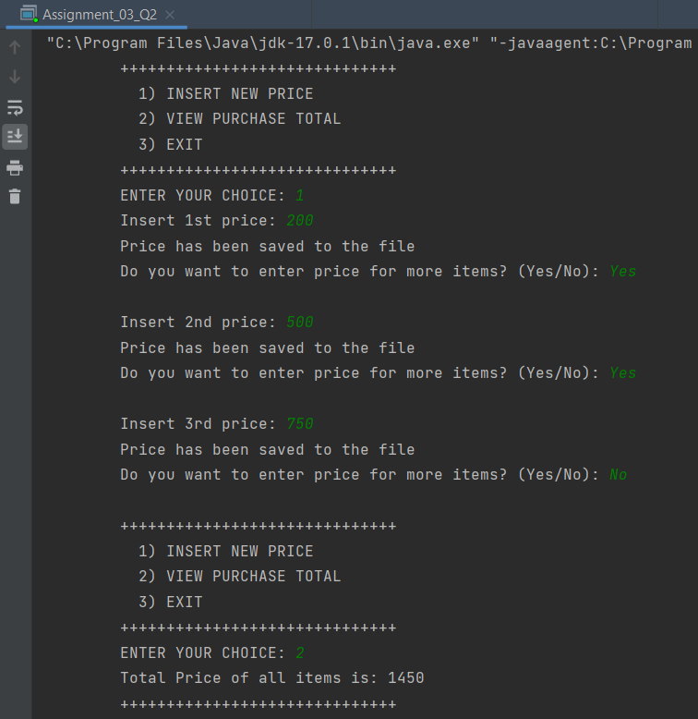

3. Write a code using HttpClient API which sends a GET request

to https://httpbin.org/get, and print out the response header, status code, and body for the given URL.

Sample output could be (Note: date and other attribute values may differ in your results):

access-control-allow-credentials:[true]

access-control-allow-origin:[*]

connection:[keep-alive]

content-length:[273]

content-type:[application/json]

date:[Fri, 06 Aug 2021 13:07:41 GMT]

server:[gunicorn/19.9.0]

200

{

"args": {},

"headers": {

"Content-Length": "0",

"Host": "httpbin.org",

"User-Agent": "Java 11 HttpClient Bot",

"X-Amzn-Trace-Id": "Root=1-610d341d-092dc33f698b192a219426d1"

},

"origin": "43.255.221.184",

"url": "https://httpbin.org/get"

}